A Master’s Project Report on

**A Comparative Study on Deblurring Methods**

**for Air Turbulence Images**

By

Blessing Ajibero

Submitted to the Graduate Faculty of the

Louisiana State University and

Agricultural and Mechanical College

Department of Computer Science and Engineering

In partial fulfillment of the requirements for the degree of

Master of Science in Computer Science

Project Advisor: Dr. Jinwei Ye

Department of Computer Science and Engineering

**Contents**

1. Introduction
2. Related Work
3. Methodology
4. Experimental Results
5. Conclusions and Discussions

**List of Figures**

Figure 1: Depicts the degradation model 5

Figure 2: Depicts the degradation to restoration process 5

Figure 3: Workflow from turbulence process to image deblurring 9

Figure 4:Ground Truths/ Original Images 10

Figure 5:Sample output of image frames with turbulence 10

Figure 6: Sample output of image frames with turbulence 11

Figure 7: Ten selected frames that shows air turbulence 11

Figure 8:Distortion Free Image 12

Figure 9 Motion Deblurring output from conventional Hyper Laplacian Prior. 14

Figure 10 Motion Deblurring output from DeblurGAN-v2 15

Figure 11: Motion Deblurring output from MPRNet 19

**1. Introduction**

Blurriness is a common problem in computer vision that causes degradation of an image. There are different types of blur which include gaussian blur, disk blur, motion blur, uniform blur and more. Atmospheric turbulence causes blurs in images [14] and removal of such distortion via deblurring has proven to be an ill-posed problem. Deblurring can be classified under image restoration and defined as an act of restoring a degraded image input to an output close to its ground truth, based on prior knowledge of the image degradation model.

This project focuses on deblurring image or frames from a video that has suffered air turbulence and removal of distortions caused by air turbulence. Temperature fluctuations in humidity, pressure, waves, air dust density, wind, hot air causes atmospheric turbulence in imagery. The presence of these fluctuations presents geometric deformation in the image scene . This geometric deformation induces degradation even after distortion removal and brings about the imperative/essential need(necessity) to improve the turbulent image. To alleviate the blurriness problem in air turbulence images, I perform a comparative study on traditional deblur techniques and deep learning algorithms on image datasets(e.g OTIS and places365 dataset). The distortions from the turbulent waves caused some sort of motion blurring. Motion blur in an image occurs as a result of movement of an object, long exposure or movement in camera while a picture is being taken. My focus was mainly on deblurring images that have been restored from turbulent distortions.

Image restoration from blurred and poorly illuminated images is difficult. This issue a deconvolution and inverse problem because the underlying image and the blur kernel is unknown. We take a blur image and perform an inverse function to create a sharp latent version of it. Diverse methods have been proposed for deblurring degraded images, however I explored both blind deconvolution and non-blind deconvolution techniques to present outstanding results. For the traditional method, I tested the Hyper Laplacian priors while for the deep learning method I utilized DeblurGAN-v2 and MPRNet neural networks. Based on this study, we qualitatively show in our experiments that deep learning methods exhibits better results when compared to conventional methods.

**2. Related Works**

**2.1 Image Blur Model**

Before learning to deblur an image, it is important to understand the modeling of image blurriness. A blurred image can be considered as a convolution function of a sharp image and a blur kernel or PSF(Point Spread Function) [15]. Mathematically, it is best explained with the degradation model as seen in Equation 1.

|  |
| --- |
| g(x) = f(x) ⨂ h(x) + n (1) |

Equation 1

where, g is the observed degraded image, f(x) is the original or latent sharp image and h(x) is some degrading function that causes the blur, ⨂ represents the convolution operator and n is additive noise. Depending on the blurring problem, h(x), which is also the blur kernel, is mostly unknown. A blur kernel estimation can be derived in cases where the PSF is unknown, but the ground truth images are available. Knowing the degradation model, we begin to look at deblurring as an inverse problem through deconvolution. Several methods via deep learning algorithms and conventional approaches have been derived to recover latent sharp images from blurred images.

**2.2 Image Deblurring Methods**

The process of image deblurring involves retrieving of sharp and finer details in an image that have been corrupted by noise or blur. There are several methods used to deblur images. The deconvolution method is the most common and can be classified into two types: blind and non-blind deconvolution. The blind deconvolution algorithm can be used effectively when no information about the distortion (blurring and noise) is known. The algorithm restores the image and the point-spread function (PSF) simultaneously. In contrast with blind deconvolution, the non-blind deconvolution uses a known point spread function and blurred image to achieve deblurring. Single image motion deblurring is traditionally treated as a deconvolution problem and can be tackled in either a blind or non-blind manner.

**2.2.1 Blind Image Deconvolution Method**

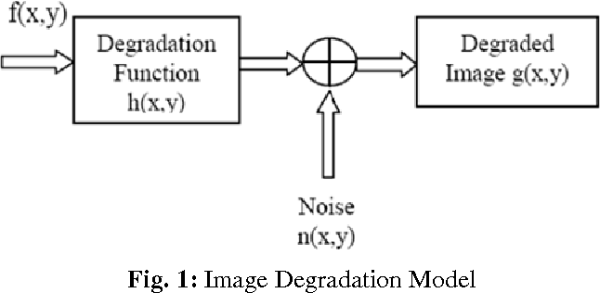

Figure 1: Depicts the degradation model

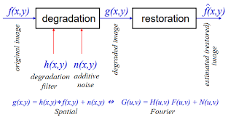

Figure 2: Depicts the degradation to restoration process

Blind image deblurring is a highly ill-posed problem because it involves deblurring without the knowledge of the blur kernel. Conventional methods use estimation algorithms to derive the blur kernel and deconvolve it with the blurry input to restore the latent sharp image. The goal of blind deconvolution is to infer both h(x) and f(x) given a single input g(x) based on the degradation function as seen in figure 1. Additionally, h(x), the blur kernel, is non-negative and smaller compared to the size of the image. A visual representation of the degradation to restoration process can be seen in figure 2 where an original image f̂(x,y) convolutes with a degradation filter with additive noise to produce the degraded image g(x,y). The degraded image becomes the new input for the deconvolution restoration process to produce an estimated or restored f(x,y). Some related works of blind image deblurring using several state-of-the-art methods include:

[1] Pan et al uses dark channel prior to achieve image deblurring. This method handles images based on sparsity as the dark channels of blurred images are observed to be less sparse than its clean image. The dark channel of clear images contains more zero-intensity pixels. They explored the sparsity of dark channels on scenarios such as text, face and low-illumination images and achieved text image deblurring, face image deblurring and non-uniform deblurring. They propose an approximate linear operator based on look-up tables for the min operator and solve the linearized L0 (ℓ0-norm regularization) minimization problem by half-quadratic splitting methods. The sparsity method is proves effective in handling kernel estimation [10].

[2] Poor image quality in digital imaging is usually caused by motion blurring. In which the image captured by a digital camera represents the scene over a period of time. If objects in a scene are moving fast or the camera is moving over the period of exposure time, the objects or the whole scene will look blurry along the direction of relative motion. Jian-Feng Cai, Hui Ji, Chaoqiang Liu, and Zuowei Shen proposed a new optimization approach to remove complex motion blurring from a single image by introducing new sparsity-based regularization terms on both images and motion-blur kernels.

[3] The quality of deblurred image depends critically upon the quality of blur kernel estimate. Kernel estimation is a difficult task to achieve because it is undisclosed and different for each type of blur. Several algorithms have been derived to obtain a precise and close to accurate blur kernel for deconvolution, nonetheless they mostly rely on assumption of the blur kernel. Mai et al proposed a method of fusing kernels from multiple existing deblurring method such that the combined kernel outperforms each individual one [4]. Fang et al proposes the separable kernel method concept to provide a more precise description of the blur effect by studying the trajectory, intensity and point spread function characteristics of the kernel [5]. They further show that the optimization of the trajectory will lead to a more accurate reconstruction of the kernel there by producing a latent sharp image. Xu et al propose a novel two-phase kernel estimation algorithm to separate computationally expensive non-convex optimization from quick kernel initialization, giving rise to an efficient and robust kernel estimation process. They also introduce a new spatial prior to preserve sharp edges in quick latent image restoration and employ the Iterative Support Detection (ISD) algorithm, which is a powerful numerical scheme through iterative support detection, to adaptively enforce the sparsity constraint and properly preserve large-value element in the kernel refinement stage. Finally, to restore the latent image, they apply a TV-1 objective function that is robust to noise and develop an efficient solver based on half-quadratic splitting [6].

Furthermore, Convolution Neural Network (CNN) approaches have become prevalent in deblurring images due to the interest in deep learning in recent times. Niu et al propose a blind motion deblurred net called BMDNet for recovering a sequence of clear images from a single motion blurred image obtained from a derived low resolution of the GoPro dataset [7]. Additionally, Nimisha et al proposes an end-to-end deep network that is kernel free for single image blind-deblurring using autoencoder and GAN (Generative Adversarial Network). The autoencoder is trained to learn the data prior while the adversarial network attempts to generate and discriminate between clean and blurred features. Once the network is trained, the generator learns a blur-invariant data representation which when fed through the decoder results in the final deblurred output [9]. Lastly, Kupyn et al present DeblurGAN which achieves state-of-the-art results when performing motion deblurring with the combination of a loss function and generator CNN architecture [10].

**2.2.2 Non-Blind Image Deconvolution Methods**

Given a known blur PSF, the process of restoring an unblurred image is referred to as non-blind deconvolution. Richardson–Lucy (RL) algorithm [17, 18] and Weiner filtering [19] are popular non-blind deblurring methods, which can give good results rapidly when the blur kernel is relatively small. Due to the fact that a perfect point spread function is unattainable, ringing and noise amplifications are inevitable artifacts in image deconvolution. Zhang et al propose a degradation model which assumes the LR (low resolution) image is a bicubically down-sampled, blurred, and noisy version of an HR (high resolution) image to develop the arbitrary blur kernels. Once the kernels are developed, it becomes a non-blind problem and use their proposed deep plug and play super resolution framework to resolve the low-resolution blurred image into a seemingly sharp image after deblurring and super resolving processes occur using a Generative Adversarial Network (GAN) [8]. Cho et al proposes a novel method that solves the ring artifacts issue present in traditional deblurring methods by handling outliers [11]. Furthermore, Fortunato and Oliveira present structured approach for high-quality non-blind deconvolution based on the use of sparse adaptive priors and applied it to images of various sizes and blur kernel size [12].

**3. Methodology** 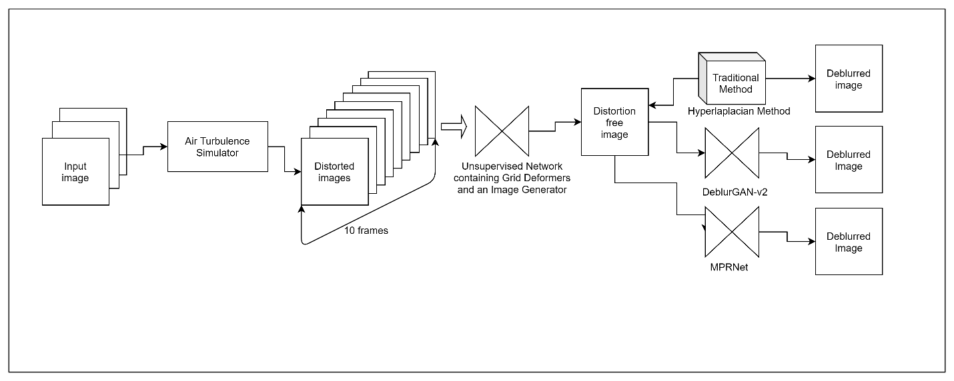

Figure 3: Workflow from turbulence process to image deblurring

In order to achieve our desired output image we split the restoration process into three parts: the air turbulence simulation, non-rigid geometric distortion removal and then image deblurring application. First, using the air turbulence simulator, as seen in figure 4, we produced turbulence induced frames from the ground truth dataset. Secondly, we introduce an unsupervised distortion grid network to re-establish a distortion-corrected image from the image frames in the previous step that show the presence of refractive mediums as a result of air turbulence. Lastly, we employ three different state-of -the art deblurring algorithms to restore the degraded image output generated in the previous step into a latent sharp image.

**3.1 Air Turbulence Simulation**

The goal of the air simulation is to achieve frames that demonstrate that when light travels non-linearly at long range from an observation point (e.g., camera) to a point of focus (e.g., a static object), it encounters refractive mediums in the atmosphere. These refractive mediums represent distortions thereby causing air turbulence in the image scene. To obtain images affected by air turbulence, we employ a 2d physics-based distortion induced simulation engine on the tested datasets on MATLAB. We used the ground truths (as seen in figure 4) from this dataset to generate 10 frames of distorted images as seen in figure 5, 6 and 7. When the distorted frames are combined as a video, one can see the turbulence flow generated. The turbulence is achieved by creating a distortion field using Fourier fast transform to calculate the kernel for deformation. The warp map and distorted frame is then saved to a folder after each iteration. It is observed that this simulation introduces both blur and non-rigid distortions.

|  |
| --- |
|  |

Figure 4:Ground Truths/ Original Images

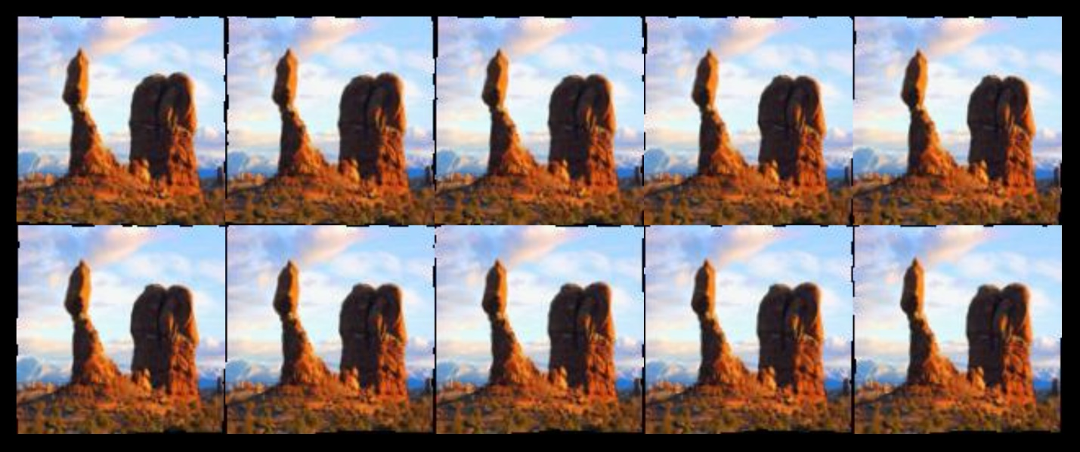

Figure 5: Sample output of image frames affected by distortions induced by the air turbulence simulator

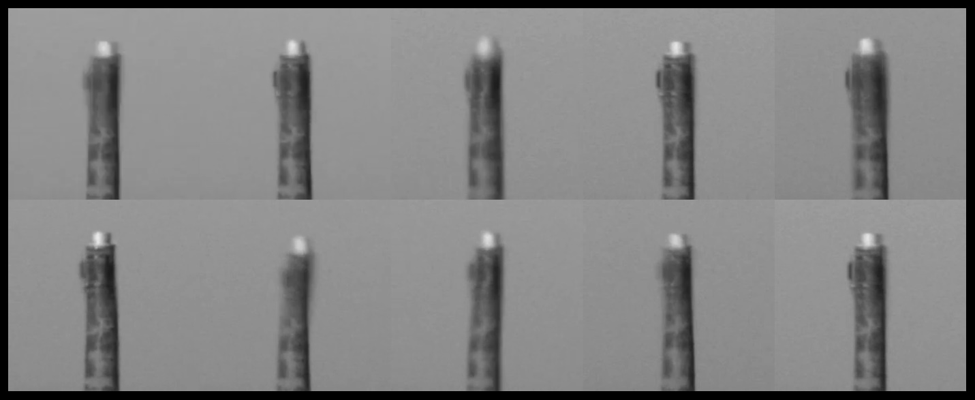

Figure 6: Sample output of image frames displaying air turbulence

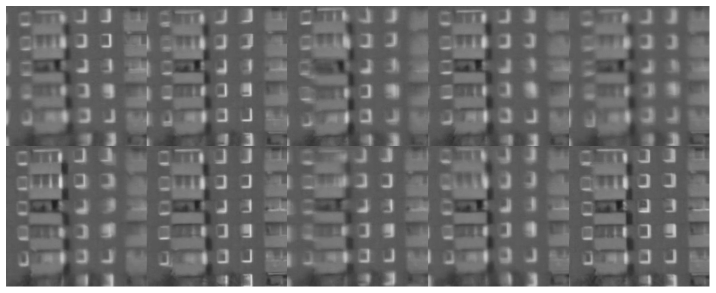

Figure 7: Ten selected frames that shows air turbulence

**3.2 Geometric Distortion Removal**

The goal of this section is to recover a latent distortion free image that has zero to no turbulence. The atmospheric turbulence removal process is implemented by two sub-networks, a grid deformer and Image generator [22]. The grid deformer deforms a uniform sampled straight grid by estimating the distortion field of the captured frames and generates a deformed grid. The Image generator then receives the deformed grids as a parameter and maps it to the corresponding image frame. If the input grid is a uniform grid then the output image is considered a distortion-free image. The architecture of the unsupervised network is presented in figure 8.

Figure 8: Architecture for the non-rigid image distortion removal network

|  |
| --- |
|  |

Figure 8:Distortion Free Image

**3.3 Image deblurring**

The issue with the distortion free images is that it suffers some blur and noise due to the turbulence corruption. To restore the image to visually look as sharp or sharper than its ground truths, we explored three main deblurring techniques using conventional methods and learning based blind and non-blind deconvolution method. The next section highlights the methods used and a comparative analysis on the results achieved.

**3.3.1 Fast Image Deconvolution Using Hyper Laplacian Prior**

The algorithm used in this method was proposed by Bai et al and the code can be found on Github (<https://github.com/BYchao100/Graph-Based-Blind-Image-Deblurring>). It handles both noise and blur, however we explored only parameters for deblurring. Bai et al presents a blind gaussian deblurring algorithm using accelerated graph spectral filtering for kernel estimation and hyper Laplacian priors for image restoration[16]. The best results on our chosen dataset are shown in figure 6. The Algorithm for this method is split into two: blur kernel estimation and restored skeleton image x. The sizes of the input image used ranges from 1024 by 1024 to 120 by 120. Since the blur kernel is unknown, It becomes a blind deconvolution problem and a kernel estimation is derived. Once a blur kernel is derived, it becomes a non-blind deblurring problem with the only unknown as the latent image. Fast Hyper Laplacian Priors method is then utilized for final image restoration. For each input, I changed the parameters of the kernel size until a visibly desired deblurred output is generated. The kernel size is different for each image based on the degree of blur and substantially smaller in size than the blurred image. The code was built and ran on MATLAB. The results from the experiment qualitatively showed that the images deblurred successfully, however some ringing effects and noise became dominant after rendering.

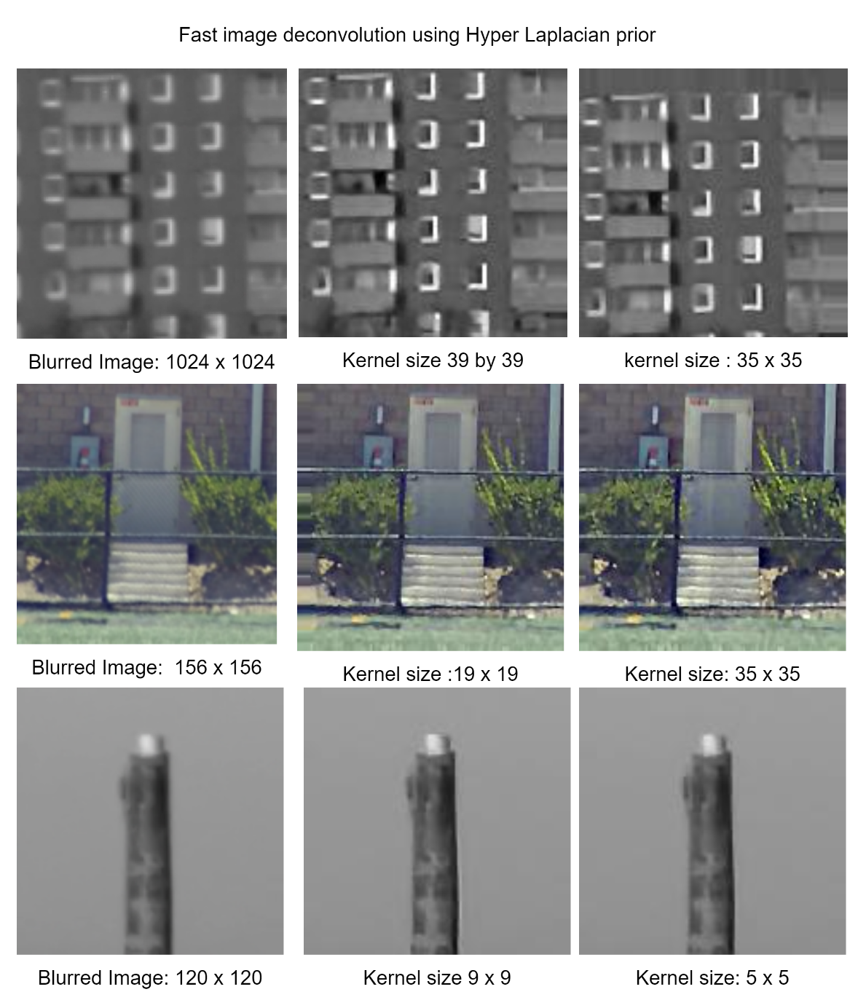

Figure 9 Motion Deblurring output from conventional Hyper Laplacian Prior. The sizes of each image is shown and the kernel sizes are much smaller than the image size.

**3.3.2 Using DeblurGAN-v2 for Deblurring**

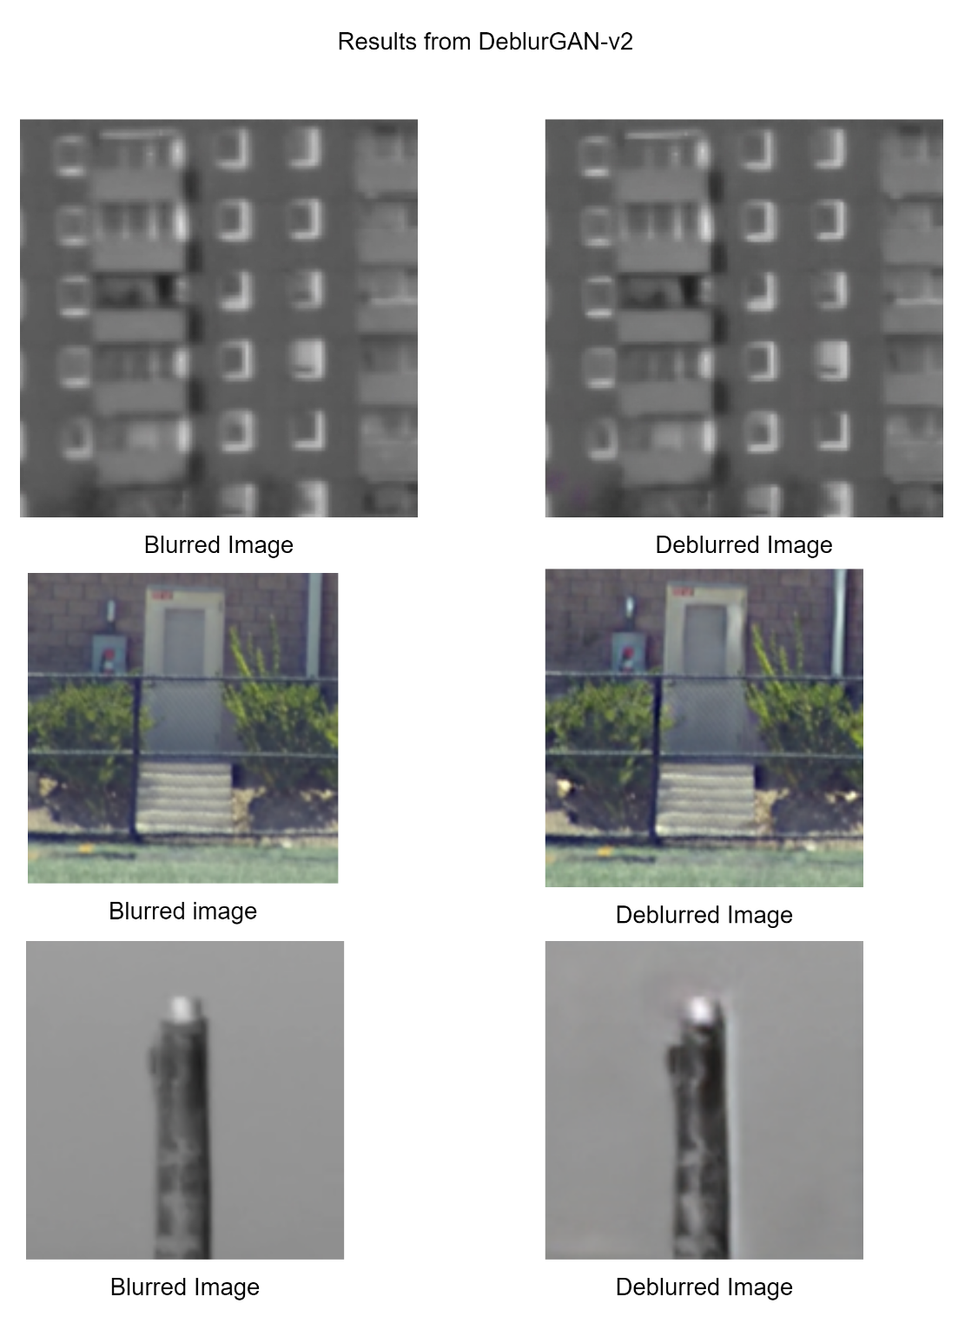

Figure 10 Motion Deblurring output from DeblurGAN-v2

DeblurGAN-v2 is the improved version of DeblurGAN discussed earlier in related works[10]. The deep learning method used was proposed by Kupyn et al and the github code can be found on <https://github.com/VITA-Group/DeblurGANv2>.[19] They introduce the idea of Feature Pyramid Network, originally designed for object detection, as an end to end generative adversarial network for single image deblurring as opposed to multi scale images developed by ResNet. FPN comprises a bottom-up and a top-down pathway as seen in figure 11. [19] The bottom-up pathway is the usual convolutional network for feature extraction, along which the spatial resolution is down sampled, but more semantic context information is extracted and compressed. Through the top-down pathway, FPNs reconstructs higher spatial resolution from the semantically rich layers. The lateral connections between the bottom-up and top-down pathways supplement high-resolution details and help localize objects. The backbone I utilized to pursue strong deblurring performance was the Inception-ResNet-v2 with the activation function as tanh. I tested my input image with patch gan and double-scale discriminator, consisting of one local branch that operates on patch levels like [13] did, and the other global branch that feeds the full input image. I did not notice much of a difference in sharpness quality between these two discriminators. Major changes became visible when the blocks/layers for testing were increased along with the number of epochs as seen in figure 11. The image size plays a huge role as the Gan could not handle images sufficiently large in size. Changes to the parameter epoch, image size, batch and block layer were carried out in the yaml configuration file. The development environment for running and implementing this code was Pytorch. Their architecture consists of an FPN backbone from which we take five final feature maps of different scales as the output. Those features are later up sampled to the same 1 4 input size and concatenated into one tensor which contains the semantic information on different levels. They additionally add two up sampling and convolutional layers at the end of the network to restore the original image size and reduce artifacts [13]

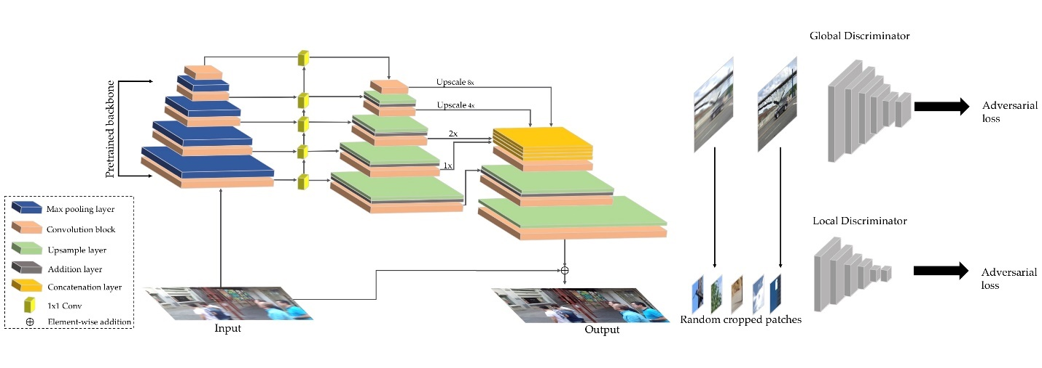

Figure 11: DeblurGAN-v2 Architecture

**3.3.3 Using MPRNet**

This is another deep learning method proposed by Zamir et al [20] using a multi-stage architecture that progressively learns restoration functions for the degraded inputs. It holds strong performance for tasks such as deraining, deblurring and denoising, however only deblurring was tested on the dataset for this project. The architecture is broken into three stages with the frameworks from the first two stages activated by encoder-decoder subnetworks and the final stage employed by a network that operates on the original input resolution of the image. The encoder-decoder network is based on standard U-NET [21] and first implements Channel Attention Blocks (CAB) for feature extraction at each scale and processes it along with it the feature maps. Also, bilinear upsampling followed by a convolution layer is utilized to reduce checkerboard artifacts. Next, ORSNET is introduced for the preservation of fine details from the input image to the output image using multiple original resolution blocks (ORB) each containing CABs. This helps generate spatially enriched high-resolution details. Next, the cross-stage feature fusion is introduced in between the two encoder-decoders (12c) and between the encoder-decoder and ORSNET (12d). Lastly, a Supervised attention module is introduced for progressive image restoration at each stage and generation of attention maps to suppress the less informative features at the current stage thereby allowing only the useful features to propagate to the next stage. Evaluation is performed on my dataset with image size of 620 by 620, 156 by 156 and 120 by 120 and results can be seen in figure 14. The results produced a sharper image quality than the DebluGAN-v2 and FHP. The shadows from the first image in figure 11 became clearer and a change in obvious changes between the blurred and deblurred image is highlighted.

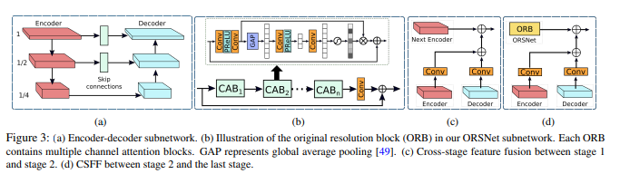

Figure 12: Overall Archithecture for MPRNET [21]

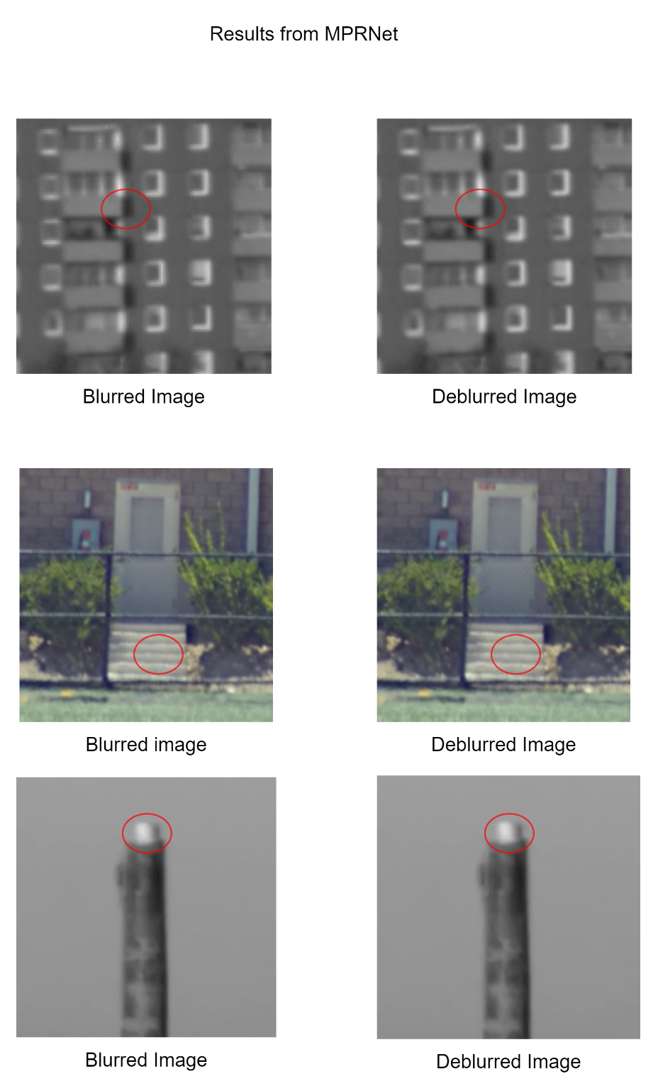

Figure 11: Motion Deblurring output from MPRNet

1. Experiments and Results

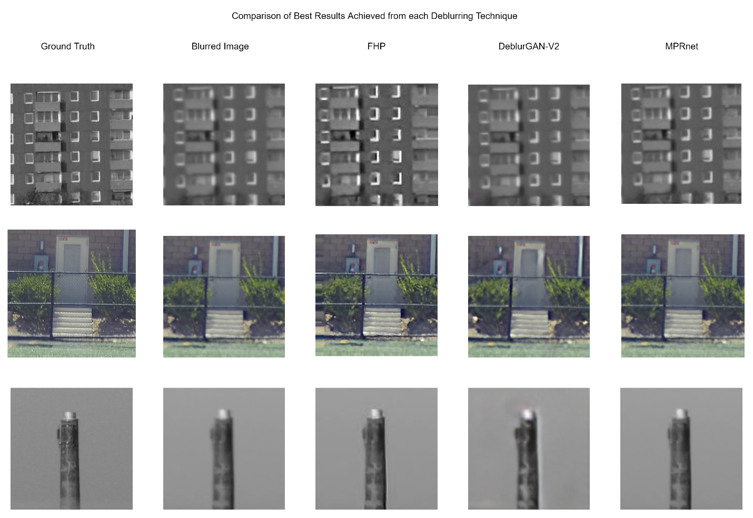

Figure 14: Comparison of Best Results Achieved from each Deblurring Technique

It can be observed that deep learning-based deblurring algorithms, in general, have more favorable qualitative results than traditional methods. The Fast Hyper-laplacian prior produces ring artifacts because the kernel estimation derived often results to an inaccurate blur kernel after deconvolution. On the other hand, DeblurGan-V2 maintains a sharper result after testing my dataset with the network. I also noticed that it provided sharper results for my first two images, however the third image shows some disparities. Lastly, MPRNet produced the best results visually compared to the ground truth and other techniques. The more I increased the epochs and layers, the better the image quality, however these iteration makes the method computationally complex.

**5. Conclusions and Discussions**

Fast Hyper Laplacian prior technique is one of the best techniques for deblurring because it produces image with rich texture if an accurate PSF is estimated however this situation rarely occurs. Also, the cons for the FHL method is the ringing and noise artifacts it produces from deconvolution due to inaccurate kernel estimation in parameter and size. In general, blind deconvolution techniques show better results in comparison with non-blind deconvolution techniques. From the qualitative analysis, we see that MPRNET produces high quality deblurred images with the cons being that it computationally expensive. DeblurGAN-v2 gets good deblurring effect and is faster than MPRNET but the results are not perceptually as good.

**6. References**

1. J. Pan, D. Sun, H. Pfister and M. Yang, "Blind Image Deblurring Using Dark Channel Prior," 2016 IEEE Conference on Computer Vision and Pattern Recognition (CVPR), 2016, pp. 1628-1636, doi: 10.1109/CVPR.2016.180.
2. J. Cai, H. Ji, C. Liu and Z. Shen, "Framelet-Based Blind Motion Deblurring From a Single Image," in IEEE Transactions on Image Processing, vol. 21, no. 2, pp. 562-572, Feb. 2012, doi: 10.1109/TIP.2011.2164413.
3. A. Levin, Y. Weiss, F. Durand and W. T. Freeman, "Understanding Blind Deconvolution Algorithms," in IEEE Transactions on Pattern Analysis and Machine Intelligence, vol. 33, no. 12, pp. 2354-2367, Dec. 2011, doi: 10.1109/TPAMI.2011.148.
4. Long Mai and Feng Liu, "Kernel fusion for better image deblurring," 2015 IEEE Conference on Computer Vision and Pattern Recognition (CVPR), 2015, pp. 371-380, doi: 10.1109/CVPR.2015.7298634.
5. L. Fang, H. Liu, F. Wu, X. Sun and H. Li, "Separable Kernel for Image Deblurring," 2014 IEEE Conference on Computer Vision and Pattern Recognition, 2014, pp. 2885-2892, doi: 10.1109/CVPR.2014.369.
6. Xu L., Jia J. (2010) Two-Phase Kernel Estimation for Robust Motion Deblurring. In: Daniilidis K., Maragos P., Paragios N. (eds) Computer Vision – ECCV 2010. ECCV 2010. Lecture Notes in Computer Science, vol 6311. Springer, Berlin, Heidelberg. https://doi.org/10.1007/978-3-642-15549-9_12
7. <https://arxiv.org/pdf/2105.13077.pdf>
8. K. Zhang, W. Zuo and L. Zhang, "Deep Plug-And-Play Super-Resolution for Arbitrary Blur Kernels," 2019 IEEE/CVF Conference on Computer Vision and Pattern Recognition (CVPR), 2019, pp. 1671-1681, doi: 10.1109/CVPR.2019.00177.
9. T. M. Nimisha, A. K. Singh and A. N. Rajagopalan, "Blur-Invariant Deep Learning for Blind-Deblurring," 2017 IEEE International Conference on Computer Vision (ICCV), 2017, pp. 4762-4770, doi: 10.1109/ICCV.2017.509.
10. O. Kupyn, V. Budzan, M. Mykhailych, D. Mishkin and J. Matas, "DeblurGAN: Blind Motion Deblurring Using Conditional Adversarial Networks," 2018 IEEE/CVF Conference on Computer Vision and Pattern Recognition, 2018, pp. 8183-8192, doi: 10.1109/CVPR.2018.00854.
11. S. Cho, Jue Wang and S. Lee, "Handling outliers in non-blind image deconvolution," 2011 International Conference on Computer Vision, 2011, pp. 495-502, doi: 10.1109/ICCV.2011.6126280.
12. Fortunato, H.E., Oliveira, M.M. Fast high-quality non-blind deconvolution using sparse adaptive priors. Vis Comput 30, 661–671 (2014). <https://doi.org/10.1007/s00371-014-0966-x>
13. Poulose, Minu. (2013). Literature Survey on Image Deblurring Techniques. International Journal of Computer Applications Technology and Research. 2. 286-288. 10.7753/IJCATR0203.1014.
14. C. J. Schuler, M. Hirsch, S. Harmeling and B. Schölkopf, "Learning to Deblur," in IEEE Transactions on Pattern Analysis and Machine Intelligence, vol. 38, no. 7, pp. 1439-1451, 1 July 2016, doi: 10.1109/TPAMI.2015.2481418.
15. Poulose, Minu. (2013). Literature Survey on Image Deblurring Techniques. International Journal of Computer Applications Technology and Research. 2. 286-288. 10.7753/IJCATR0203.1014.
16. Y. Bai, G. Cheung, X. Liu and W. Gao, "Graph-Based Blind Image Deblurring From a Single Photograph," in IEEE Transactions on Image Processing, vol. 28, no. 3, pp. 1404-1418, March 2019, doi: 10.1109/TIP.2018.2874290.
17. Richardson, W. (1972). Bayesian-Based Iterative Method of Image Restoration. Journal of the Optical Society of America, 62, 55-59..
18. Lucy L. An iterative technique for the rectification of observed distributions. Astron J. 1974;79(6):745–54.
19. O. Kupyn, T. Martyniuk, J. Wu and Z. Wang, "DeblurGAN-v2: Deblurring (Orders-of-Magnitude) Faster and Better," 2019 IEEE/CVF International Conference on Computer Vision (ICCV), 2019, pp. 8877-8886, doi: 10.1109/ICCV.2019.00897.
20. Zamir, S.W., Arora, A., Khan, S., Hayat, M., Khan, F., Yang, M., & Shao, L. (2021). Multi-Stage Progressive Image Restoration. ArXiv, abs/2102.02808.
21. Olaf Ronneberger, Philipp Fischer, and Thomas Brox. UNet: convolutional networks for biomedical image segmentation. In MICCAI, 2015. 1, 2, 3
22. Nianyi Li, Simron Thapa, and Jinwei Ye, " Unsupervised Non-Rigid Image Distortion Removal via Grid Deformation," 2021 submitted to IEEE/CVF International Conference on Computer Vision (ICCV).